 | <Project Name>  Technical Design Document
 | Prepared By / Last Updated By | Reviewed By | Approved By
Name | Vijayadithya Doddi
Role | DEVELOPER
Signature | VD
Date | 12/02/2019

Table of Contents

1.0 Introduction 3
1.1 Purpose of this document 3
1.2 Project overview 3
2.0 Solution Summary 3
2.1 Scope 3
2.2 Assumptions 3
2.3 Dependencies 3
2.4 Risks 3
3.0 Schematic Diagram 3
4.0 System Design 4
4.1 Proposed design 4
4.2 Component inventory 4
5.0 Database Design 4
5.1 Data Model 4
5.2 Tables Structure 4
6.0 Appendices 4
6.1 Glossary 4
6.2 Other 5
7.0 Terms & Conditions 5
8.0 Change Log 5

Introduction

Purpose of this document
The purpose of this document is to document the technical design, component details and Database design. This will also capture the scope, assumptions, risk, dependencies of this project.

Project overview
Below are the objectives that shall be fulfilled post the execution of this project:
- User registration & credential authentication
- Shop manager registration & credential authentication
- Search available products
- Stock Management

Solution Summary

Scope
<This sub-section shall state the scope of this detailed design document>

Assumptions
- For sorting the displayed products in the customers view, popularity was mentioned. There was no clear way to sort based on popularity. Hence this functionality was dropped in the end.
- The user’s role structure was not clearly defined. Customer was assigned user type “U” (USER), for shop manager user type “A” (ADMIN) was assigned and a new third user called SUPER was created and assigned the user type “S”.
- The registration of a shop manager by admin was not clear. If user was to login and create a shop manager account, there was no need for approvals. So the registration was page was made common with option to select the account type. Shop manager registration were by default made pending “P” in status and are changed late by super user’s approval page.
- Aisle and shelf update was incorporated into the product edit component.
- The data tables in the document for product history only stores 10 products per purchase, the data table structure was altered to add any number of products to a particular bill.

Dependencies
<This sub-section shall state the dependencies for this project>

Risks
- A product in the purchase history is used as a foreign key and cannot be deleted

Schematic Diagram
A schematic, or schematic diagram, is a representation of the elements of a system using abstract, graphic symbols rather than realistic pictures. It gives an overview of overall system
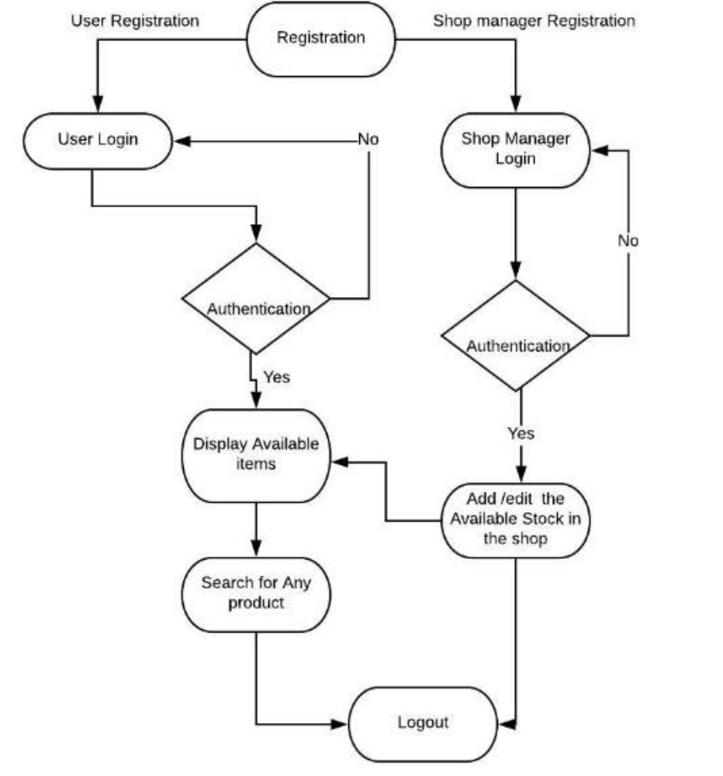

System Design

Proposed design
<This sub-section shall elaborate the high-level design for this project>

Component inventory
<This sub-section shall list the components for this project>

Database Design

Data Model
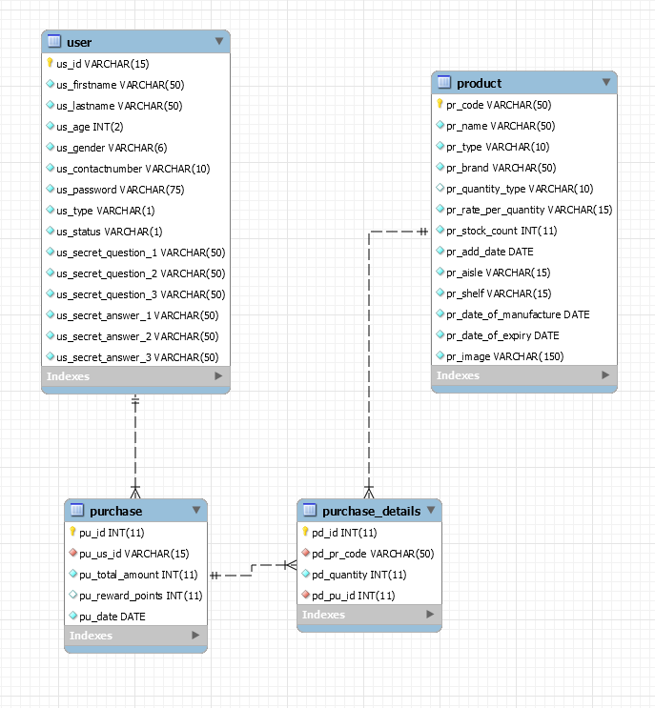

Tables Structure

Product Table
Column Name | Data Type | Length | Nulls
pr_code | VARCHAR | 50 | Not Allowed
pr_name | VARCHAR | 50 | Not Allowed
pr_type | VARCHAR | 10 | Not Allowed
pr_brand | VARCHAR | 50 | Not Allowed
pr_quantity_type | VARCHAR | 10 | Not Allowed
pr_rate_per_quantity | VARCHAR | 15 | Not Allowed
pr_stock_count | INT | 11 | Not Allowed
pr_add_date | DATE | NA | Not Allowed
pr_aisle | VARCHAR | 15 | Not Allowed
pr_shelf | VARCHAR | 15 | Not Allowed
pr_date_of_manufacture | DATE | NA | Not Allowed
pr_date_of_expiry | DATE | NA | Not Allowed
pr_image | VARCHAR | 150 | Not Allowed

Purchase Table
Column Name | Data Type | Length | Nulls
pu_id | INT | 11 | Not Allowed
pu_us_id | VARCHAR | 15 | Not Allowed
pu_total_amount | INT | 11 | Not Allowed
pu_reward_points | INT | 11 | Allowed
pu_date | DATE | NA | Not Allowed

Purchase Details Table
Column Name | Data Type | Length | Nulls
pd_id | INT | 11 | Not Allowed
pd_pr_code | VARCHAR | 50 | Not Allowed
pd_quantity | INT | 11 | Not Allowed
pd_pu_id | INT | 11 | Not Allowed

User Details Table
Column Name | Data Type | Length | Nulls
us_id | VARCHAR | 50 | Not Allowed

Appendices

Glossary
Acronyms | Definitions

Other

Terms & Conditions
Interns shall be solely responsible for all its acts and omissions under this program. Interns will comply at all times with all applicable laws. Interns shall not use Cognizant’s name, logo and trademark in any promotional materials or other communications with third parties without the prior written consent of Cognizant. Any materials used by interns in relation to program will not infringe the copyrights, trademarks, patents, trade secrets or other intellectual property rights, privacy or similar rights of any person or entity. Interns agrees not to post, draw, make, display any content that is threatening, libelous, obscene, defamatory, abusive, pornographic, or advocates/encourages any conduct that could constitute a criminal offence or give rise to any civil liability. Cognizant its associates’ personal details including but not limited to name, address, contact number shall not be shared or forwarded to any third party, without prior written consent of Cognizant, its associates. All intellectual property provided by Cognizant, as part of program shall be owned exclusively by Cognizant. Intern shall indemnify, defend and indemnify Cognizant its associates, officers, directors from and against any claims, demands, loss, damage, liability, causes of action, judgments, or costs and expenses of every nature (including attorney’s fees and expenses) incurred by Cognizant based on any claim that any breach of terms and conditions of this program

Change Log
Please note that this table needs to be maintained even if a Configuration Management tool is used.
Version Number | Changes made
V<n.n> | <If the change details are not explicitly documented in the table below, reference should be provided here>
V<n.n> | Page no | Changed by | Effective date | Changes effected

